2D game construction in Swift

CS39440 Major Project Report

Author: Petter Vang Brakalsvålet ([Pev2@aber.ac.uk](mailto:Pev2@aber.ac.uk))

Supervisor: Dr/Prof. Chris Price([cjp@aber.ac.uk](mailto:cjp@aber.ac.uk))

24th March 2021

Version 0.1 (Draft)

This report is submitted as partial fulfilment of a BSc degree in  
Computer Science (With Integrated Year In Industry)

(G401)

Department of Computer Science

Aberystwyth University

Aberystwyth

Ceredigion

SY23 3DB

Wales, UK

Declaration of originality

I confirm that:

* This submission is my own work, except where clearly indicated.
* I understand that there are severe penalties for Unacceptable Academic Practice, which can lead to loss of marks or even the withholding of a degree.
* I have read the regulations on Unacceptable Academic Practice from the University’s Academic Registry (AR) and the relevant sections of the current Student Handbook of the Department of Computer Science.
* In submitting this work, I understand and agree to abide by the University’s regulations governing these issues.

Name …………………………………………

Date ……………………………………………

Consent to share this work

By including my name below, I hereby agree to this project's report and technical work being made available to other students and academic staff of the Aberystwyth Computer Science Department.

Name …………………………………………

Date ……………………………………………

Acknowledgements

I am grateful to…

I’d like to thank…

Abstract

Contents

1. Background, Analysis & Process 7

1.1. Background 7

1.2. Analysis 7

1.3. Process 8

1.3.1. Sprint 1 & 2 8

1.3.2. Sprint 3 & 4 9

1.3.3. Sprint 5 9

1.3.4. Sprint 6 9

1.3.5. Sprint 7 9

1.3.6. Sprint 8 (Final Sprint) 9

2. Design 9

2.1. Overall Architecture 9

2.1.1. Update 10

2.1.2. Physics 11

2.1.3. Constraints 11

2.1.4. Rendering 12

2.2. Detailed Design 12

2.2.1. MainMenu 12

2.2.2. Help 12

2.2.3. Set-up 12

2.2.4. GameScene 12

2.3. User Interface Design 12

2.3.1. Start screen assets 14

2.3.2. Game scene assets 16

2.3.3. User interface 18

3. Implementation 19

4. Testing 20

4.1. Overall Approach to Testing 20

4.2. Automated Testing 20

4.2.1. Unit Tests 20

4.2.2. User Interface Testing 20

4.2.3. Stress Testing 20

4.2.4. Other Types of Testing 20

4.3. Integration Testing 20

4.4. User Testing 20

5. Critical Evaluation 21

7. Annotated Bibliography 22

8. Appendices 23

8.1. Review of similar games 23

8.1.1. Hide ‘N Seek! 23

8.1.2. Hide‘N Find 23

8.1.3. Hide & Seek Fun Game 23

8.1.4. Hide and Seek..! 23

A. Third-Party Code and Libraries 24

B. Ethics Submission 26

C. Code Samples 29

# Background, Analysis & Process

## Background

**How I started:**

Upon deciding that I wanted to make a 2D game with swift, I started by researching online to figure out where to start with my project. I started by watching a YouTube video playlist called “Beginning SpriteKit” by raywenderlich.com [1] to give myself an introduction to this type of iOS development.

I was also given a book by my supervisor called “2D Apple Game Development” by Tutorials. [1] This book walked me though how to create a simple game and gave me the starting point I needed to begin designing and developing.

**Research:**

To find out what the target audience already thought of this type of game, I investigated pre-existing Hide and Seek games on the AppStore. Here I found that there were a few games which fit into the same niche as mine, and only a couple of them had good reviews. However, I discovered that those with bad reviews were more helpful for my research, as they gave feedback on which features worked and which didn’t (from a user’s point of view). I found that all the games were “fun” and “addictive”. I also discovered that those which allowed customisation of the game had better reception from the users than those which didn’t offer this feature. Most of the games locked the player into one role (hider or seeker) and they had a pre-defined game duration. It appeared that these features were the main turn-offs for the users, as they gave a limiting game experience,

**Motivation:**

My motivation for creating this game was that I had some experience with iOS development, but I had never done any game development. I thought this would be a good challenge for myself and it would be an opportunity for me to develop my skills whilst experiencing a new industry of mobile development. I was also inspired by Among Us [2] (a multiplayer game which rose in popularity during the COVID-19 Pandemic) which I spent a considerable amount of time playing. This was the main inspiration for the layout of the game and the interactions between players and bots.

## Analysis

My original task was to create a hide and seek based game where the player would play against bots. The player would be able to choose what role they would play (hider or seeker) and how long the game would last.

After I did some research, I found out that customizability of the game and player interaction with the world is very important to create a successful game. I decided to make this my focus. To make my game more customizable, I gave the players the option of changing settings when they start a game (these settings include: the player’s role; the reach, speed; the difficulty level and how many bots the game is going to have). By doing this, I ensured that the players could play a game personalised for their ideal gameplay as opposed to a universal standard gameplay.

I also discovered that I could use SpriteKit (and their integrated physics engine) or the creation of my own parameters to track interference and node interaction. This meant I could handle player interaction much more efficiently.

Through using SpriteKit’s physics engine, I had the ability to assign physics bodies to nodes and specify what each node will collide with. If the nodes are in the same height layer, they will collide into each other(automatically). It has the functionality to handle all the collisions for me while also allowing me to specify if I want something else to happen or if I want to change the Physic body delegate.

However, there is also the opportunity for me to handle these situations manually. This would be done by checking if a node is intersecting with another node and then handling the collisions and interactions. This is a less intensive way, which is better for the device running the game, but it wouldn’t be as reliable as using SpriteKit’s built-in features. I decided to use a combination of both these methods.

My combination approach was as follows: the physics engine handled collisions between nodes, but I manually handled hiding, catching, or freeing of bots and players. By doing it like this, I created a less intense game which maintained the robustness given by SpriteKit and its physics engine.

## Process

I tried to use an agile approach to develop this game, where I split my time into separate sprints. Each sprint gave me an opportunity to divide up the work and prioritise them based on importance. I also used stories to track the work and measure my progress. Each sprint was a 2-week period, beginning with a small planning session and culminating in a review and retrospective. This gave me opportunities to review and improve my working practices, while also ensuring all the work was completed by the respective deadlines.

Here is a brief overview of what happened in each sprint:

### Sprint 1 & 2

In the beginning, I focused on learning how to develop 2D games for iOS and how to build a library of game assets. I started by creating assets for the game, and by the end of Sprint 2 I had created the majority of the assets needed. Through Sprint 2 to Sprint 4, I worked through Chapter 1 to 3 of 2D Apple game by tutorials. This gave me a basic understanding of Game development for iOS.

### Sprint 3 & 4

In Sprint 3, I investigated similar games and in Sprint 4, I tested the most popular games. This gave an idea of which features to include and which to leave out. I found that most of the popular games had lots of customisation for the player, and that they give the player the option to choose which role they will have.

In Sprint 3, I also started to create the game. I began by creating the main menu and setting up a help page, but I didn’t add any content to the help page. After this, I created a game setup page, and I added a simple game scene.

### Sprint 5

During Sprint 5, I finished the last chapters of the “Getting Started” section of the 2D Apple games book. After this point, a lot of technical work started to get done and my focus shifted to building a “functioning” game.

### Sprint 6

In Sprint 6, I added the players, tents and house and I expanded the environment. Since I now had players in the game, I worked on developing the player interaction. I also gave the player the option to hide (if they are a hider) and to catch other players (if they are a seeker). Due to this addition, I added functionality to the game setup page. The player would now be able to set their role, the number of bots and many more settings. One problem was that the players would always see the full screen; to fix this, I added a camera and made the camera move with the player.

### Sprint 7

In Sprint 7, I added bots and collision detection to the game. This made the player interaction less predictable, which would need to be improved in the future. I now had a functioning game, but I didn’t have any bot movement. I decided to prioritise adding automatic tests, and I added a victory check to the game instead.

### Sprint 8 (Final Sprint)

In the final sprint, I focused on the documentation instead of programming as I had most of the functionality complete. However, I added some content to the help page. I had some tasks left in backlog which I didn’t have time to implement. Some of the features I didn’t have time to add were pausing, trees, bot movement, and the finish page.

# Design

## Overall Architecture

For my project I used a SpriteKit architecture. I did this because SpriteKit is Apple’s own framework developed for 2D game development and it can handle different actions, physics, and constraints. SpriteKit runs in a loop and does different steps (see image below). 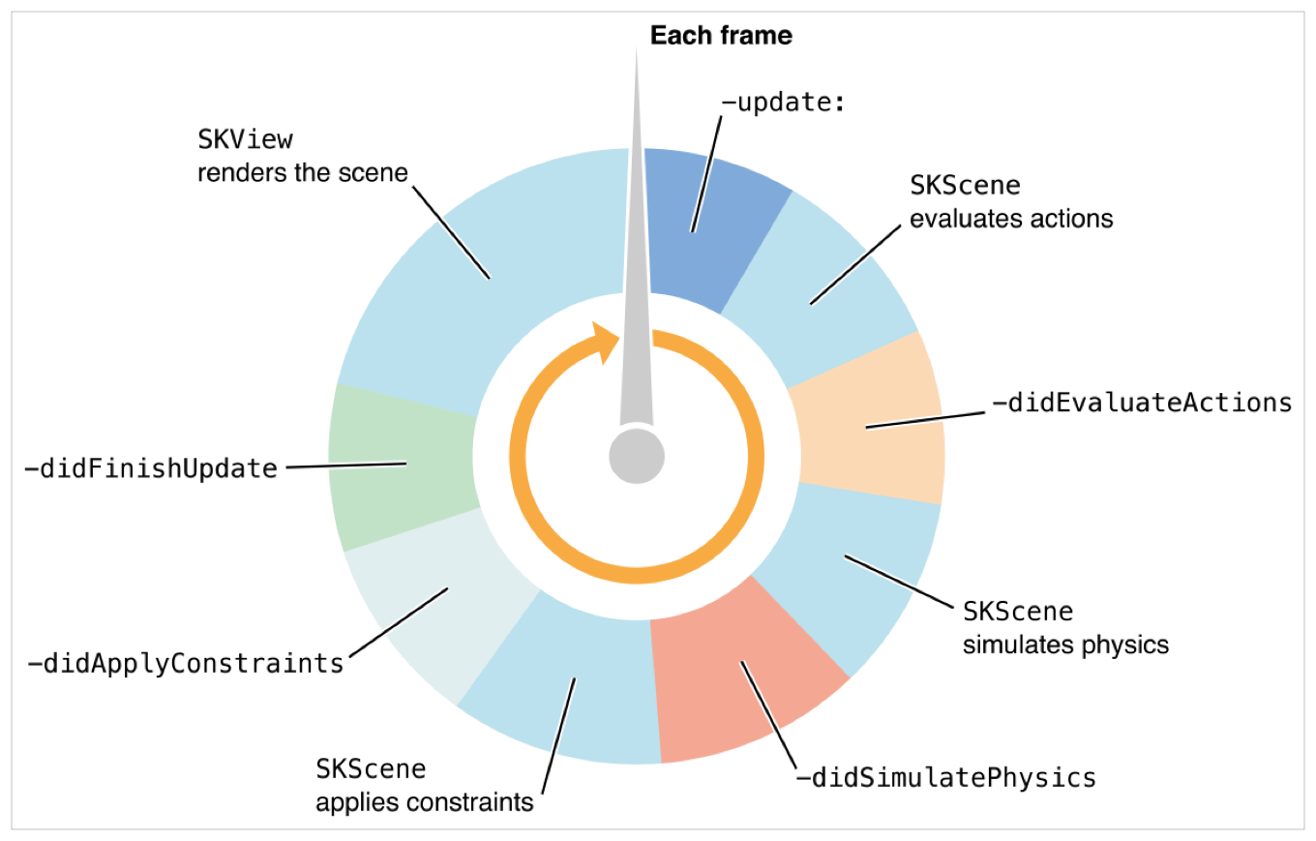

Figure 1 SpriteKit loop. See developer.apple.com [3]

I split the functions up into four groups which I will explain in the sections below.

### Update

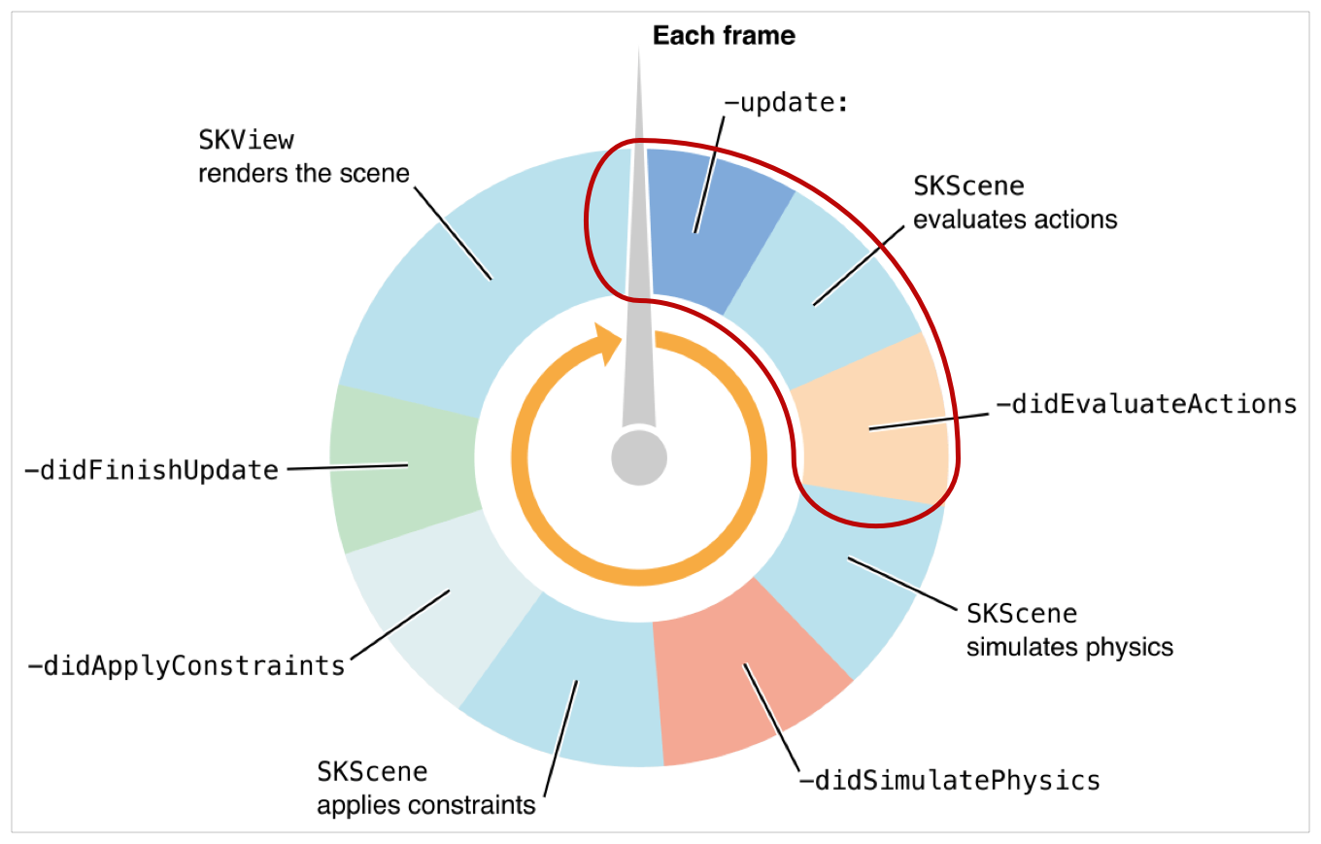

The first section of functions to be run in a frame is updating the section. This section is where most of the code for the game is performed. I used this section for updating the movement for all nodes, and I used this to handle the player interactions.

### Physics

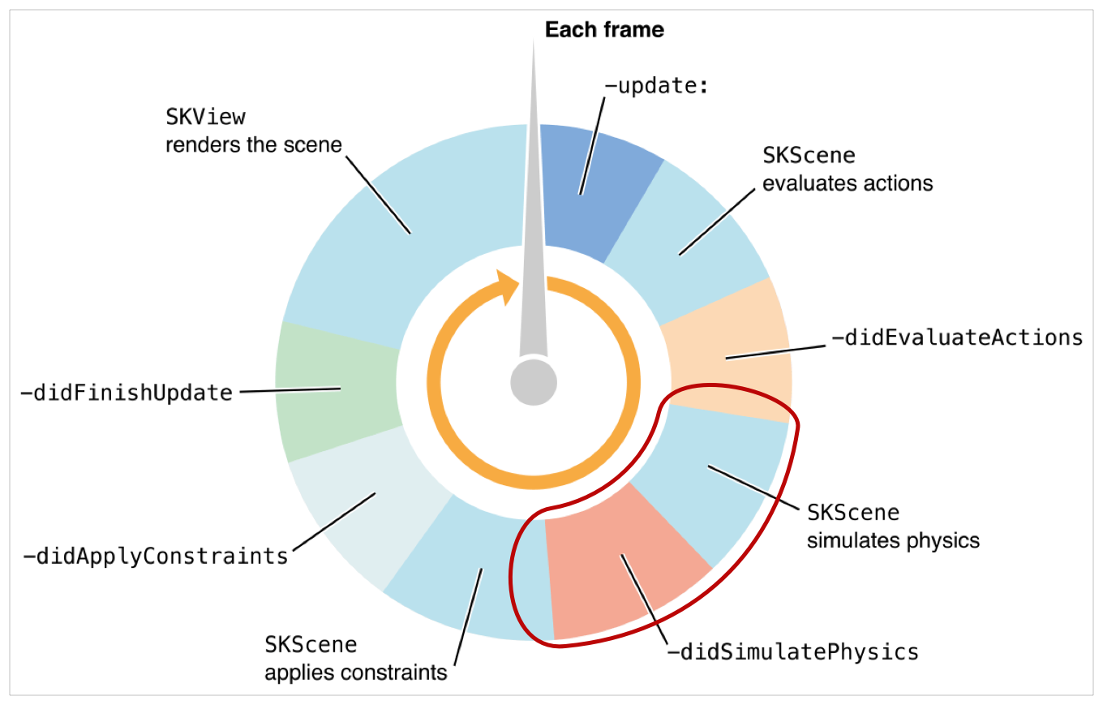

This section handles the simulation of physics. SpriteKit can simulate some real-world physics like gravity and collisions, and this happens in this section. I’m using a physics simulation to handle the collisions in my game.

### Constraints

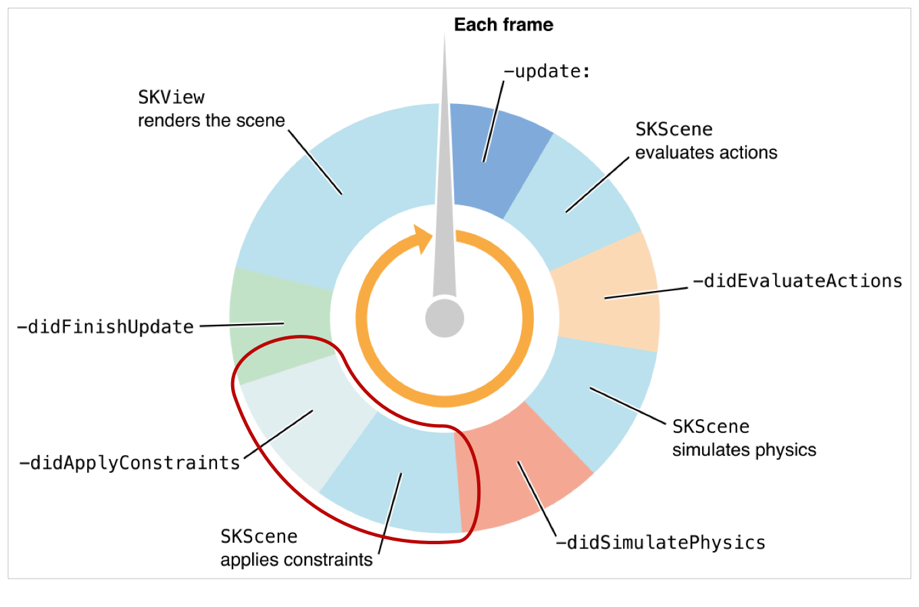

In this section, constraints will be applied to the nodes of the game. I didn’t use any constraints for my game and I handled this by using collision detection instead to get a more responsive collision. However, this section can be used to set relationships between nodes. This means that I could have multiple nodes pointing in the same directions and use constraints to make this happen.

### Rendering

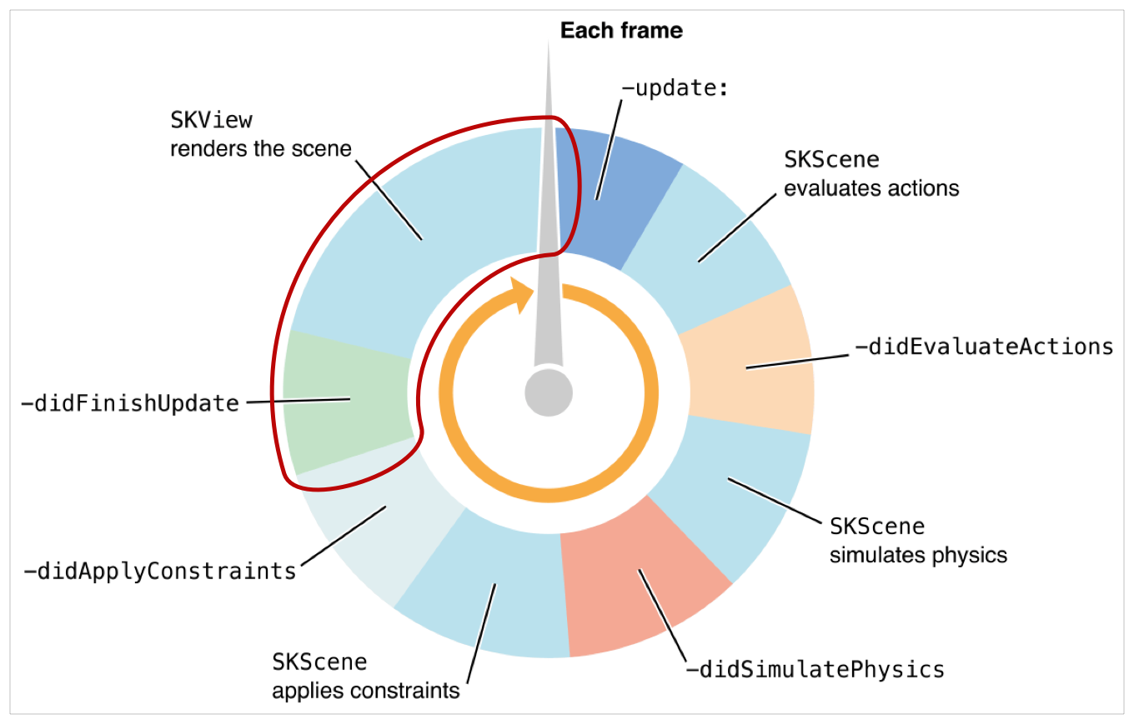

This section handles the rendering of the game assets. This automatically chooses what resolution is to be used for a node. Most game assets have three resolution variants for each asset, so that this section can use the one which is needed.

## Detailed Design

I have split my project into multiple folders to structure the project and make it more readable. I will explain here what each folder contains and what the files do.

### MainMenu

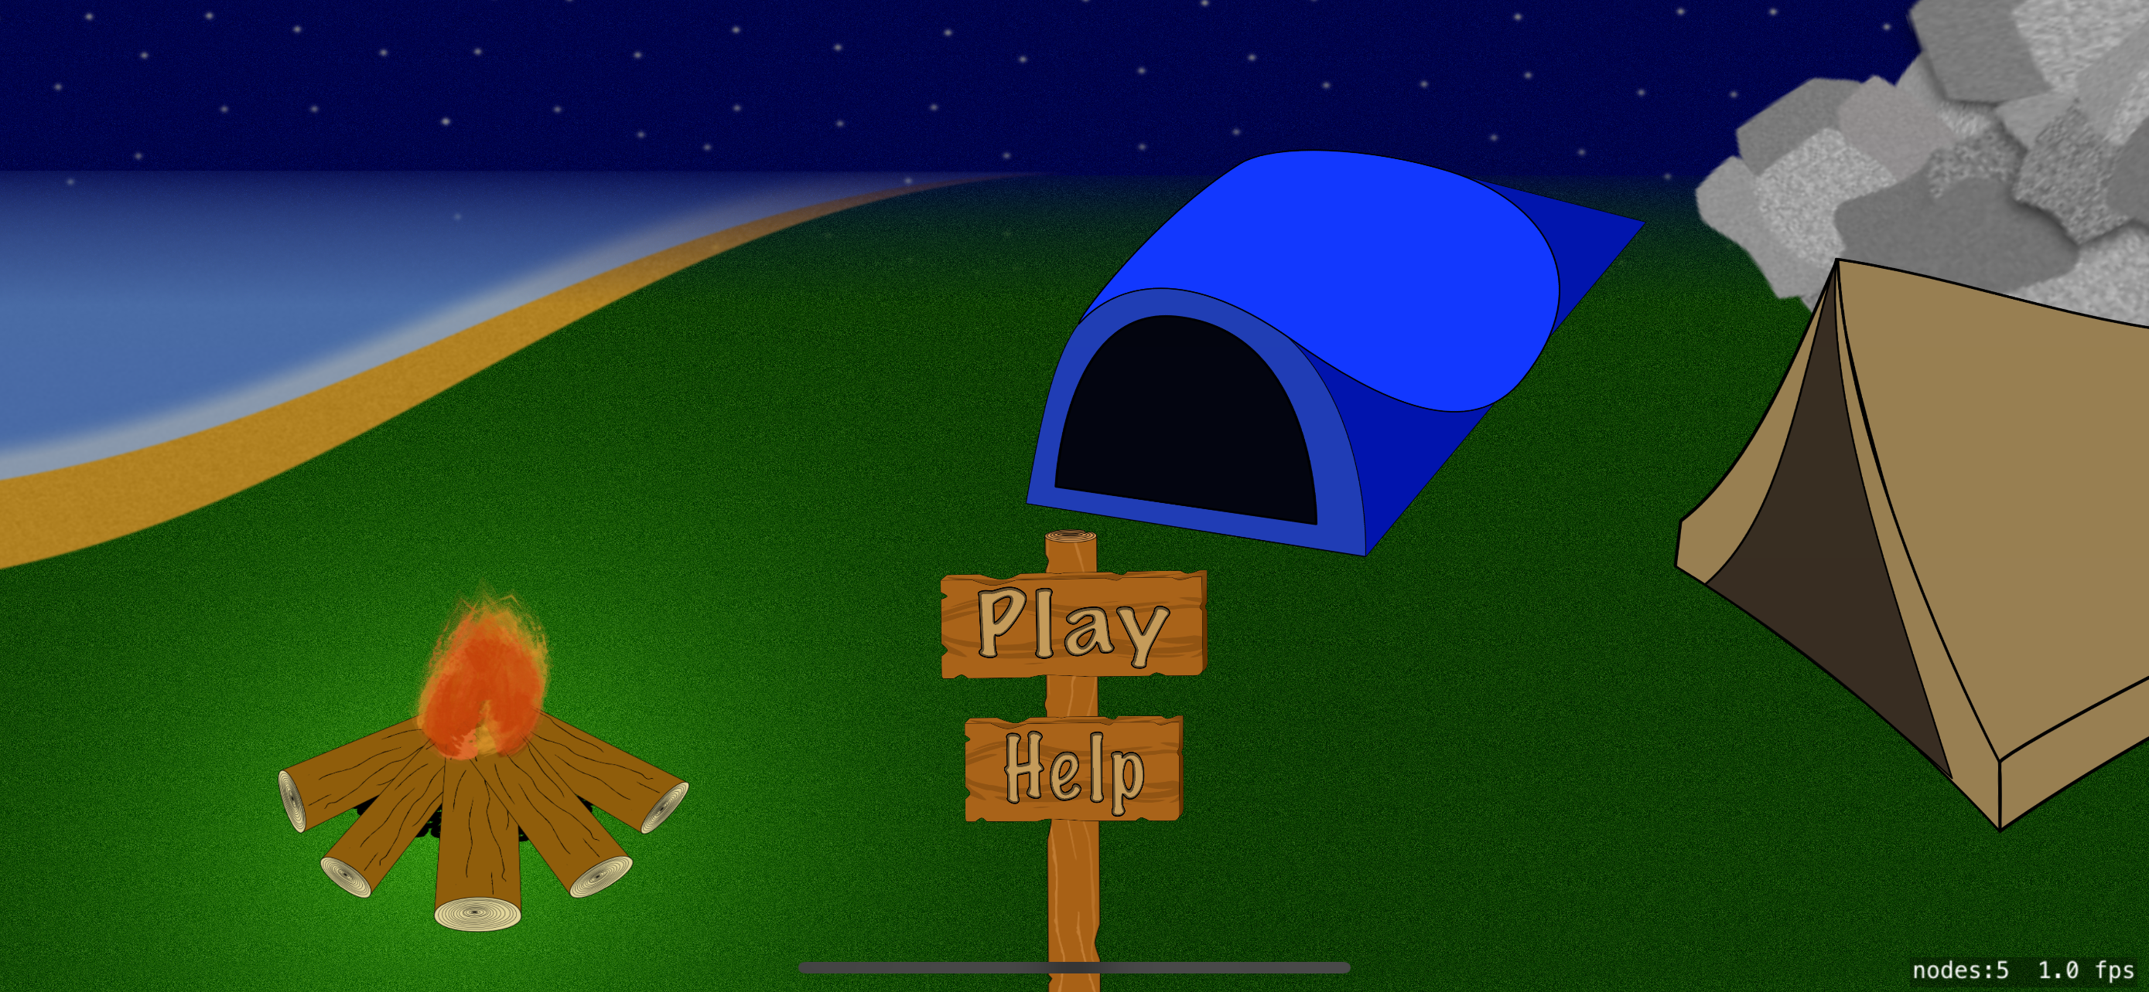

This is the main menu screen where the player can choose to start the game or go to the help page. This scene is designed to show some of the aspects of the game, such as light coming from the campfire, tents to hide in and the mountain in the background.

The mainMenu folder contains all files needed to display the screen and to handle the inputs that might come from the screen.

#### MainMenuVC.swift

This file will load a SpriteKit scene and display it in the view. This file is inheriting from UIViewController so that I can display and handle the data in a specific way.

#### MainMenuScene.sks

This file is a SpriteKit scene file, and here I have created the main menu scene.

#### MainMenu.swift

This file is a SpriteKit scene file. It’s here where all the programming for the main menu is and it’s here, I’m handling actions from the scene. Since this file is handling actions happening in MainMenuScene.sks. It is inheriting from SKScene so that I can overridden some of the functions to handle the data.

### Help

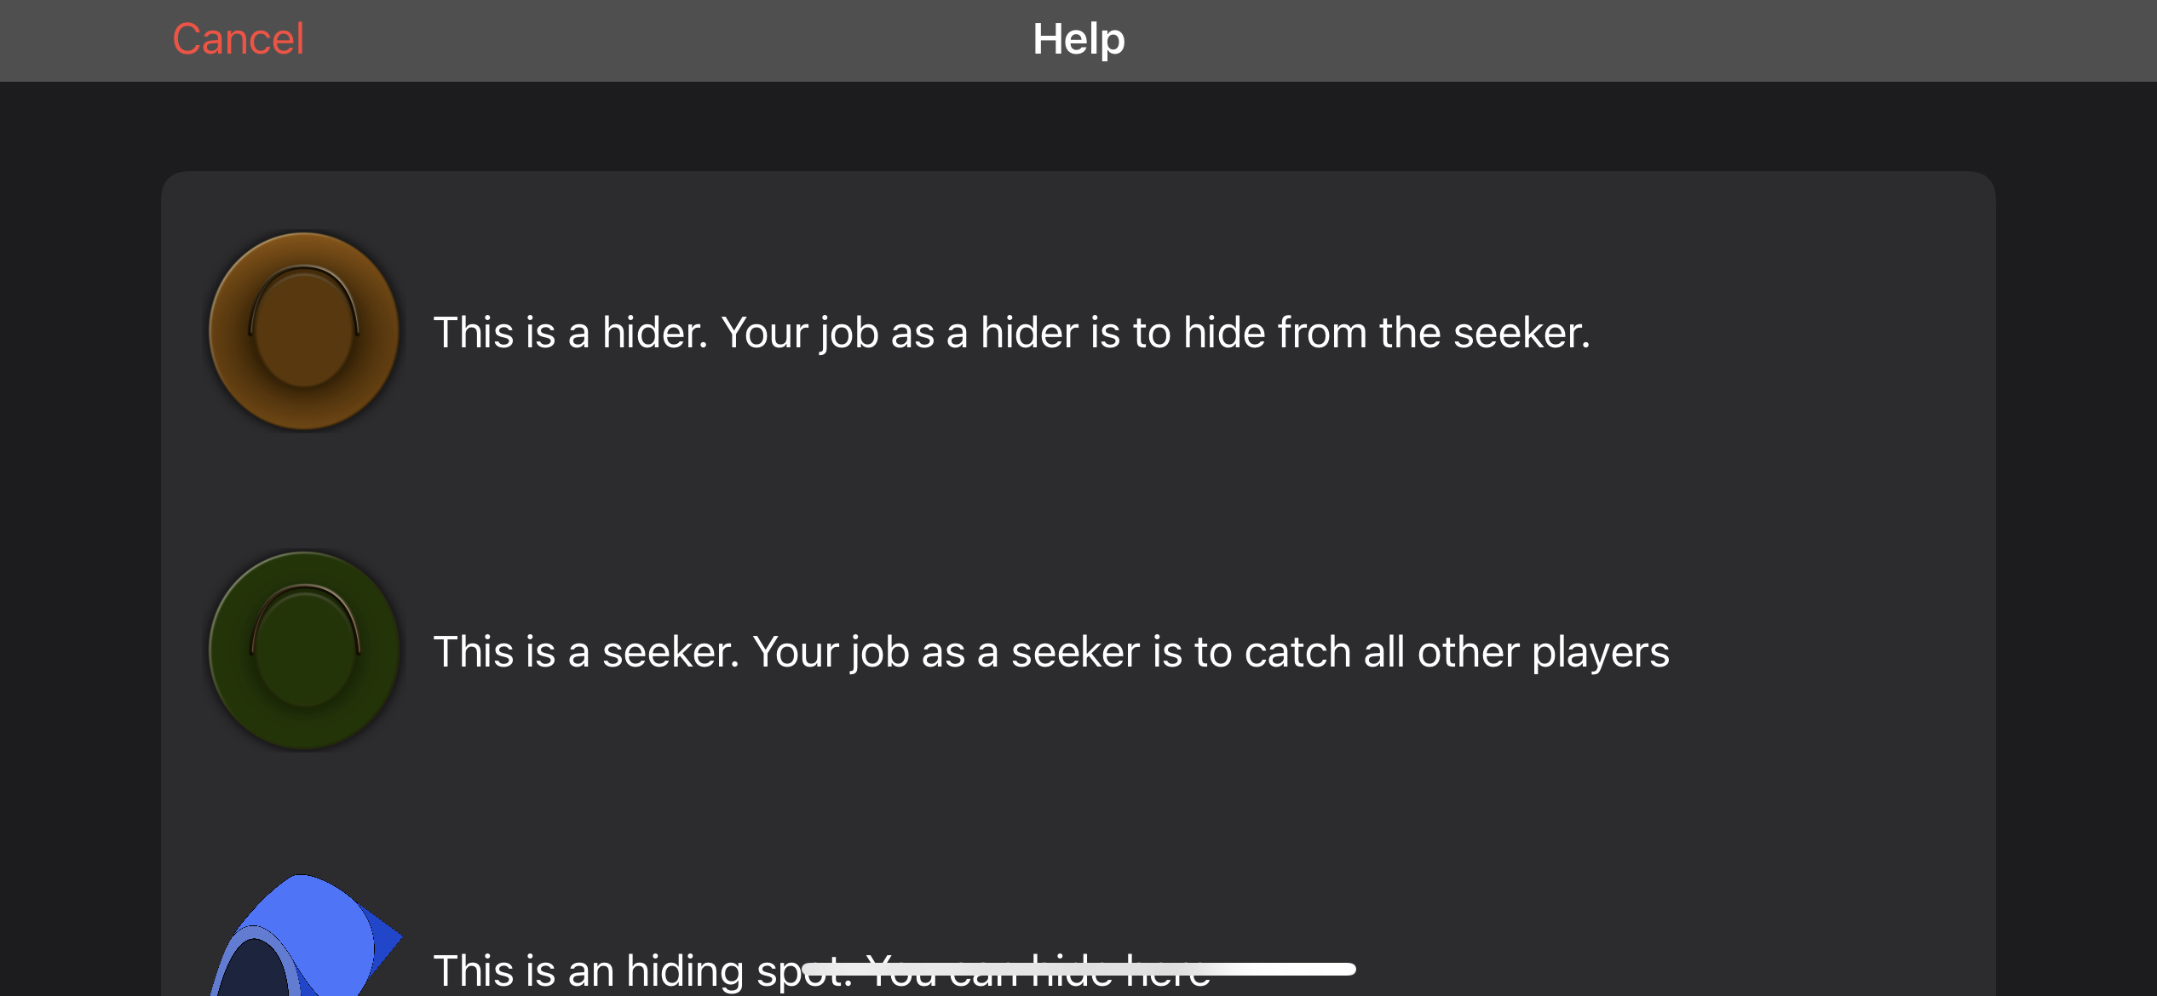

This is the help page. It has a brief description of what some items are and their purpose.

This folder contains the files related to the Help screen.

#### HelpVC.swift

This file will generate the help items and display the help data.

The help data is created by using a struck called HelpItem, this struck specifies the data needed for each HelpItem. Each HelpItem needs to have one image and an explanation of the image, but they have an optional second image. The second image will be displayed on top of the first image.

This file is inheriting from UIViewController, UITableViewDelegate and UITableViewDataSource. I’m using a UITableView to display and organise the data, and since I’m using a UITableView I need to override some functions so that I can supply the data to the UITableView and so I can handle user input.

#### HelpCell.swift

This file is my custom cell and it’s inheriting from UITableViewCell. The cell is created by the UITableView in HelpVC.swift and then this fill will display the data in a specific format.

### SetUp

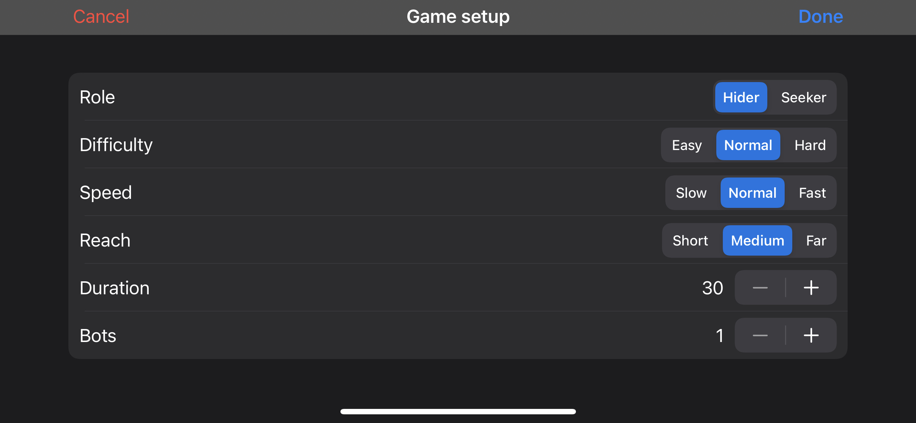

This scene is where the user can customise the game to their preferences. The player can set all of these to what they prefer, but the duration and bots options are limited to minimum 30 seconds or maximum 6 minutes and a minimum of 1 bot or maximum 5 bots.

#### SetUpVC.swift

This file will generate the different options the user has to customise the game and display the options. The game options are created by using a struck called GameOption, this struck specifies the data needed for each GameOption. Each GameOption needs to have a title and specify if it has segments or not. It also has an optional segments variable; this is an array of all the segments needed for this GameOption.

This file is inheriting from UIViewController, UITableViewDelegate and UITableViewDataSource. I’m using a UITableView to display and organise the data, and since I’m using a UITableView I need to override some functions so that I can supply the data to the UITableView and so I can handle user input. This UITableView can have 2 different cells to display the data. This depends on if the GameOption has segments or not.

#### SegmentCell.swift

This file is my custom cell and it’s inheriting from UITableViewCell. The cell is created by the UITableView in SetUpVC.swift and then this fill will display the data in a specific format.

#### StepperCell.swift

This file is my custom cell and it’s inheriting from UITableViewCell. The cell is created by the UITableView in SetUpVC.swift and then this fill will display the data in a specific format.

### GameScene

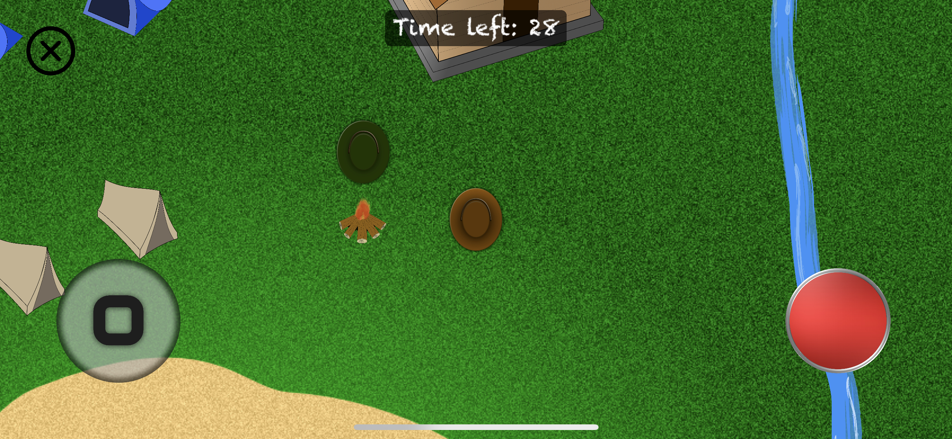

This is the game scene. This scene contains some static UI (the joystick to the left of the screen and the button to the right of the screen). The player is in the centre of the screen as a brown hat. There are some tents and a house where the hiders can hide. The green hat on the screen is the seeker, and in this case, it’s played by a bot. The player has a set reach, and if the players’ reach intersects with another node, it will reveal a label under the button on the right stating the action available. At the top of the screen there is a timer counting down how much time you have until the game is finished.

#### GameSceneVC.swift

This is the view controller file for the game scene and It’s inheriting from UIViewController. It will handle closing of the game scene and load the game scene.

#### GameScene.swift

This is the game scene itself, unlike the main menu this scene is created programmatically. This file will display and handle the game and its mechanics. This file will handle all the touches and how this will affect the nodes in the scene.

### Models

#### HidingSpot.swift

This is a class to store all the data and functions need for a hiding spot. This class contains a Enum called Variant which all the different hiding spots in the game. This Enum can return a string of the Variant. This class will create a SKSpriteNode and assign the values to it automatically.

#### Player.swift

This is a class to store all the data and functions need for a player. This class contains three Enums called Role, Reach, Speed. Theses Enums are created to make the class more readable and sores certain values for the different options. This class will create a SKSpriteNode and assign the values to it automatically. This class contains functions for checking what actions that can be performed, running of animations and checking if the players reach is intersecting with any others.

#### Bot.swift

This is a class to store data relating a bot. This class is inheriting from the Player class since a bot and a player are very similar. However, this class is overriding some of the functions so that they can create a bot and not a player.

### Extensions.swift

This is a file containing any Enums, or any other functions that needs to be reached by the whole project. The Enums here are ChallangeRating, ColliderType. These store specific values for different cases. In this file I’m also extending on SKSpriteNode with a function that can change the size of a SKSpriteNode but also keep the aspect ratio of the texture used by the SKSpriteNode.

This file contains some functions from 2D Apple Games by Tutorials [4] These functions are only to simplify mathematics in the code are copyrighted. The copyright is stated before the functions in question.

### Main.storyboard

## User Interface Design

### Start screen assets

Unless otherwise stated, all assets have been designed and produced by myself using Affinity design.

#### Play button

|  |  |
| --- | --- |
|  | This is a button for the main menu, It’s a plank with the written option on it. |

#### Help button

|  |  |  |
| --- | --- | --- |
|  | This is a button for the main menu, It’s a plank with the written option on it. |  |

#### Stick

|  |  |
| --- | --- |
|  | This is a stick for the main menu. I have the other main menu options on it as a sign with different labels. |

#### Start screen

|  |  |
| --- | --- |
|  | This is the background image for the start screen. This is a snapshot of the game in action and is designed to show what can happen. |

### Game scene assets

#### Campfire

|  |  |
| --- | --- |
|  | This is a simple campfire. |

#### Mountain

|  |  |
| --- | --- |
|  | This is a mountain created for the left side of the map. |

#### Game background

|  |  |
| --- | --- |
|  | This is the background image for the game scene. |

#### River

|  |  |
| --- | --- |
|  | This is a simple river to cut off the map. |

#### Hider

|  |  |
| --- | --- |
|  | This indicates a “hider”. It’s supposed to look like a hat from top down. |

#### Seeker

|  |  |
| --- | --- |
|  | This indicates a “seeker”. It’s supposed to look like a hat from top down. |

#### Tent new

|  |  |
| --- | --- |
|  | This is a tent where a player can hide. |

#### Tent old

|  |  |
| --- | --- |
|  | This is a tent where a player can hide. |

#### House

|  |  |
| --- | --- |
|  | This is a house where multiple people can hide. |

### User interface

#### Button

|  |  |
| --- | --- |
|  | This is a generic button. I found it on <https://pixabay.com/illustrations/generic-button-button-3d-sign-1357003/> under the license of **Pixabay License (**[**https://pixabay.com/service/license/**](https://pixabay.com/service/license/)**)** |

#### Joystick background

|  |  |
| --- | --- |
|  | This is a plain background I created for the joysticks. |

#### Joystick node

|  |  |
| --- | --- |
|  | This is the joystick itself. |

# Implementation

# Testing

## Overall Approach to Testing

## Automated Testing

### Unit Tests

### User Interface Testing

### Stress Testing

### Other Types of Testing

## Integration Testing

## User Testing

# Critical Evaluation

# Annotated Bibliography

|  |  |
| --- | --- |
| [1] | raywenderlich.com, “Beginning SpriteKit,” youtube.com, 20 06 2017 . [Online]. Available: https://www.youtube.com/watch?v=wrEEIX2fUxE&list=PL23Revp-82LIKiBNSJaF311ixNvSzk8LC. [Accessed 01 2020]. |
| [2] | InnerSloth LLC, “Among us,” 09 08 2019. [Online]. Available: https://apps.apple.com/us/app/among-us/id1351168404. [Accessed 11 2020]. |
| [3] | Apple Inc, “Responding to Frame-Cycle Events,” 2021. [Online]. Available: https://developer.apple.com/documentation/spritekit/skscene/responding_to_frame-cycle_events. [Accessed 24 04 2021]. |
| [4] | SUPERSONIC STUDIOS LTD, “Hide 'N Seek!,” 2020 06 24. [Online]. Available: https://apps.apple.com/gb/app/hide-n-seek/id1491654968. [Accessed 08 03 2021]. |
| [5] | W. Zhong, “Hide'N Find,” - - -. [Online]. Available: https://apps.apple.com/gb/app/hiden-find/id1509189851. [Accessed 08 03 2021]. |
| [6] | Y. Majeed, “Hide & Seek Fun Game,” - - -. [Online]. Available: https://apps.apple.com/gb/app/hide-seek-fun-game/id1495168019. [Accessed 08 03 2021]. |
| [7] | funcell Games Pvt Ltd, “Hide and Seek..!,” 30 10 2020. [Online]. Available: https://apps.apple.com/gb/app/hide-and-seek/id1537051480. [Accessed 08 03 2021]. |
| [8] | M. B. M. B. A. H. M. T. a. R. W. Caroline Begbie, 2D Apple Games by Tutorials Second Edition, raywenderlich.com: Razeware LLC, 2017. |

# Appendices

## Review of similar games

### Hide ‘N Seek!

This is a free and popular online game, it has an average rating of 4.7 and is number 37 in the Action category. This game takes place in a maze where the hiders need to outlast the seeker and the other hiders.

|  |  |
| --- | --- |
| Positive | Negative |
| The game is fun and addictive, and people can be freed by other players when they have been captured. | The game has too many ads and they aren’t age appropriate for a 4+ game. The game has a lot of data tracking and most of the data collected is linked to you. |

<https://apps.apple.com/gb/app/hide-n-seek/id1491654968> [4]

### Hide‘N Find

This is a free offline game with an average rating of 3.3. The game takes place in a box where there are some walls to hide behind.

|  |  |
| --- | --- |
| Positive | Negative |
| The game isn’t tracking any data nor linking any data to you. | The game has a hyper focused seeker that only targets you, and the seeker can reach through walls to catch you. |

<https://apps.apple.com/gb/app/hiden-find/id1509189851> [5]

### Hide & Seek Fun Game

This is a free offline game with an average rating of 3.7. The game takes place in a jungle with a pyramided in the centre of the map.

|  |  |
| --- | --- |
| Positive | Negative |
| This game gives you some customisability in the form of changing controls, changing outfit and game difficulty. | The game has a hyper focused seeker that only targets you. You have no indication of who the seeker is. It has a messy user interface, and the game has too many ads. |

<https://apps.apple.com/gb/app/hide-seek-fun-game/id1495168019> [6]

### Hide and Seek..!

This is a free offline game with an average rating of 2.5. The game takes place at a house where the hiders are invisible and you, as the seeker, have to find them.

|  |  |
| --- | --- |
| Positive | Negative |
| The game looks very nice and has a good user interface. The game has also included physics in the game with object falling when moving too close. | The game forces you to be the seeker, and the controls are very sensitive. The field of view is very small which makes it very hard to find someone. |

<https://apps.apple.com/gb/app/hide-and-seek/id1537051480> [7]

* 1. Third-Party Code and Libraries

I have used some third-Party code in my project. The code I have used is functions to handle simple mathematics in a more user-friendly way. The code and the copyright associated with the code I have used can be found bellow.

**Copyright** (c) 2017 Razeware LLC

Permission is hereby granted, free of charge, to any person obtaining a copy of this software and associated documentation files (the "Software"), to deal in the Software without restriction, including without limitation the rights to use, copy, modify, merge, publish, distribute, sublicense, and/or sell copies of the Software, and to permit persons to whom the Software is furnished to do so, subject to the following conditions:

The above copyright notice and this permission notice shall be included in all copies or substantial portions of the Software.

Notwithstanding the foregoing, you may not use, copy, modify, merge, publish, distribute, sublicense, create a derivative work, and/or sell copies of the Software in any work that is designed, intended, or marketed for pedagogical or instructional purposes related to programming, coding, application development, or information technology. Permission for such use, copying, modification, merger, publication, distribution, sublicensing, creation of derivative works, or sale is expressly withheld.

THE SOFTWARE IS PROVIDED "AS IS", WITHOUT WARRANTY OF ANY KIND, EXPRESS OR IMPLIED, INCLUDING BUT NOT LIMITED TO THE WARRANTIES OF MERCHANTABILITY, FITNESS FOR A PARTICULAR PURPOSE AND NONINFRINGEMENT. IN NO EVENT SHALL THE **AUTHORS** OR COPYRIGHT HOLDERS BE LIABLE FOR ANY CLAIM, DAMAGES OR OTHER LIABILITY, WHETHER IN AN ACTION OF CONTRACT, TORT OR OTHERWISE, ARISING FROM, OUT OF OR IN CONNECTION WITH THE SOFTWARE OR THE USE OR OTHER DEALINGS IN THE SOFTWARE.

func + (left: CGPoint, right: CGPoint) -> CGPoint {

return CGPoint(x: left.x + right.x, y: left.y + right.y)

}

func += (left: inout CGPoint, right: CGPoint) {

left = left + right

}

func - (left: CGPoint, right: CGPoint) -> CGPoint {

return CGPoint(x: left.x - right.x, y: left.y - right.y)

}

func -= (left: inout CGPoint, right: CGPoint) {

left = left - right

}

func * (left: CGPoint, right: CGPoint) -> CGPoint {

return CGPoint(x: left.x * right.x, y: left.y * right.y)

}

func *= (left: inout CGPoint, right: CGPoint) {

left = left * right

}

func * (point: CGPoint, scalar: CGFloat) -> CGPoint {

return CGPoint(x: point.x * scalar, y: point.y * scalar)

}

func *= (point: inout CGPoint, scalar: CGFloat) {

point = point * scalar

}

func / (left: CGPoint, right: CGPoint) -> CGPoint {

return CGPoint(x: left.x / right.x, y: left.y / right.y)

}

func /= ( left: inout CGPoint, right: CGPoint) {

left = left / right

}

func / (point: CGPoint, scalar: CGFloat) -> CGPoint {

return CGPoint(x: point.x / scalar, y: point.y / scalar)

}

func /= (point: inout CGPoint, scalar: CGFloat) {

point = point / scalar

}

extension CGPoint {

func length() -> CGFloat {

return sqrt(x*x + y*y)

}

func normalized() -> CGPoint {

return self / length()

}

var angle: CGFloat {

return atan2(y, x)

}

}

let π = CGFloat.pi

func shortestAngleBetween(angle1: CGFloat, angle2: CGFloat) -> CGFloat {

let twoπ = π * 2.0

var angle = (angle2 - angle1).truncatingRemainder(dividingBy: twoπ)

if angle >= π {

angle = angle - twoπ

}

if angle <= -π {

angle = angle + twoπ

}

return angle

}

extension CGFloat {

func sign() -> CGFloat {

return self >= 0.0 ? 1.0 : -1.0

}

}

extension CGFloat {

static func random() -> CGFloat {

return CGFloat(Float(arc4random()) / Float(UInt32.max))

}

static func random(min: CGFloat, max: CGFloat) -> CGFloat {

assert(min < max)

return CGFloat.random() * (max - min) + min

}

}

* 1. Ethics Submission

Image not found or type unknown

11/03/2021

For your information, please find below a copy of your recently completed online ethics assessment

Next steps

Please refer to the email accompanying this attachment for details on the correct ethical approval route for this project. You should also review the content below for any ethical issues which have been flagged for your attention

Staff research - if you have completed this assessment for a grant application, you are not required to obtain approval until you have received confirmation that the grant has been awarded.

Please remember that collection must not commence until approval has been confirmed.

In case of any further queries, please visit [www.aber.ac.uk/ethics](https://www.aber.ac.uk/ethics) or contact ethics@aber.ac.uk quoting reference number 19208.

**Assesment Details**

AU Status

Undergraduate or PG Taught

Your aber.ac.uk email address pev2@aber.ac.uk

Full Name

Petter Vang Brakalsvalet

Please enter the name of the person responsible for reviewing your assessment.

Neil Taylor

Please enter the aber.ac.uk email address of the person responsible for reviewing your assessment nst@aber.ac.uk

Supervisor or Institute Director of Research Department

cs

Module code (Only enter if you have been asked to do so) CS39440

Proposed Study Title

2D game construction in Swift

Proposed Start Date 25 January 2021

Proposed Completion Date 1 June 2021

Are you conducting a quantitative or qualitative research project? Mixed Methods

Does your research require external ethical approval under the Health Research Authority? No

Does your research involve animals? No

Does your research involve human participants? Yes

Are you completing this form for your own research? Yes

Does your research involve human participants? Yes

Institute

IMPACS

Please provide a brief summary of your project (150 word max)

My aim is to create a hide and seek style 2D game for iOS. This game will take place at night in a forest. The players will have multiple places to hide. However, some of the hiding places will have some form of punishment depending on how good of a hiding spot it is. For example, if a player hides in a tent the player would rustle the tent and make a noise, or if they are hiding in a tree they will get tired and eventually fall down. When a player takes the role of a seeker, they will have the option to use a flashlight to extend their field of view, and if another player is within reach the seeker can catch them. When a player is caught they will be frozen in place until another player frees them or the game finishes. When the game finishes they will be greeted with a new page where they will be able to see who was caught and who wasn’t. I might ask other people to test my game and to provide some feedback.

I can confirm that the study does not involve vulnerable participants including participants under the age of 18, those with learning/communication or associated difficulties or those that are otherwise unable to provide informed consent? Yes

I can confirm that the participants will not be asked to take part in the study without their consent or knowledge at the time and participants will be fully informed of the purpose of the research (including what data will be gathered and how it shall be used during and after the study). Participants will also be given time to consider whether they wish to take part in the study and be given the right to withdraw at any given time. Yes

I can confirm that there is no risk that the nature of the research topic might lead to disclosures from the participant concerning their own involvement in illegal activities or other activities that represent a risk to themselves or others (e.g. sexual activity, drug use or professional misconduct). Yes

I can confirm that the study will not induce stress, anxiety, lead to humiliation or cause harm or any other negative consequences beyond the risks encountered in the participant’s day-to-day lives. Yes

Please include any further relevant information for this section here:

Where appropriate, do you have consent for the publication, reproduction or use of any unpublished material? Not applicable

Will appropriate measures be put in place for the secure and confidential storage of data? Yes

Does the research pose more than minimal and predictable risk to the researcher? No

Will you be travelling, as a foreign national, in to any areas that the UK Foreign and Commonwealth Office advise against travel to? No

Please include any further relevant information for this section here:

Is your research study related to COVID-19? No

If you are to be working alone with vulnerable people or children, you may need a DBS (CRB) check. Tick to confirm that you will ensure you comply with this requirement should you identify that you require one. Yes

Declaration: Please tick to confirm that you have completed this form to the best of your knowledge and that you will inform your department should the proposal significantly change. Yes

Please include any further relevant information for this section here:

* 1. Code Samples